**RE Department**

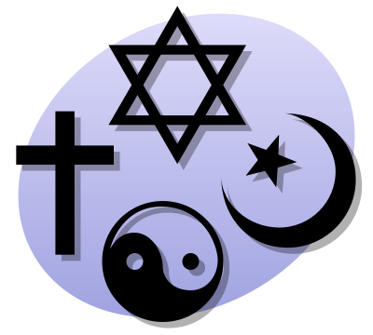

**Religion and Society (Unit 8)**

**Christianity**

**GCSE RS Revision Guide**

**Religion and Social Responsibility**

**Using the Bible to make moral decisions**

Some Christians use only the Bible because…

BUT others do not think it is overly important because it was written by humans, inspired by God

* It is the word of God (absolute authority)
* Has God’s teachings on how to behave e.g. the Decalogue
* Has Jesus’ teachings on how to live e.g. Sermon on the Mount
* Records Jesus’ actions which Christians want to follow

**Using the Church to make moral decisions**

The Church explains the Bible for today. It can do this because…

* The Church is the ‘Body of Christ’
* God speaks to the world today through the Church
* By following the Church all believe the same thing
* Church authority for RCs comes from the **Magisterium**

**Using the Conscience to make moral decisions**

* Believe it is God speaking to them
* Church says they should follow their conscience
* St Paul the conscience should be the last part of the decision making process

Some do not use it because…

* Could be mistaken e.g. **Yorkshire Ripper**
* Follow the **Church** or the **Bible** means all do the same
* Life would be chaotic if everyone did their own thing and not what the Law said

**Using Situation Ethics to make moral decisions**

Founded by Joseph Fletcher. Should do most loving thing in any situation. Some use it because…

* Jesus acted in a similar way
* Should only do things that lead to good results
* Jesus’ said ‘love thy neighbour’
* Christianity is a religion based on love

Some do not use it because…

* Bible is the word of God which should not over ruled
* Christians should all do the same thing
* Church knows what is best
* Can never know all of the facts

Why use a variety of sources to make decisions?

*Protestants might use the Bible for things like adultery. Hard to do this with modern issues like contraception. May then turn to the Church or their own conscience.*

**Human Rights in the UK**

Examples are ‘Freedom from slavery’, ‘Freedom from torture’, ‘The right to life’ and the ‘Right to a fair trial’.

**Why human rights are important to Christians**

* Right to life is covered by teaching of sanctity of life
* All humans made in God’s image and are equal
* Christians are protected by these laws and so should help protect others
* Human rights ban discrimination

Can cause problems for Christians because…

* Some are against civil partnerships which are legal in the UK
* Some against marrying outside their religion
* Against homosexuals having a family (adoption)
* RC do not allow women priests, which is a form of discrimination

**Democratic and electoral processes**

We should take part in democratic and electoral processes because…

* Government decides on taxes and voting gives you some control
* They make new laws which you could influence
* You get a say in things like schools and the NHS
* People fought for the right to vote and this should be respected

**Christian teachings on moral duties and responsibilities**

1. The Golden Rule – *‘Do to others as you would have them do to you.’* When voting Christians should look at policies and see how they would affect others living in this country e.g. not vote for a party that wanted to send asylum seekers home.
2. Parable of the sheep and the goats – States that you will be judged on how you have treated others. Christians would not vote for a party who wanted to cut benefits for the disabled or those in need.
3. Am I my brother’s keeper – This refers to when Cain killed his brother Abel. Christians have a duty to look after everyone who is in need. The is the main principle behind human rights.

**Nature of Genetic Engineering and Cloning**

**Non-religious arguments FOR**

* Could lead to cures for usually incurable diseases
* Using ‘cybrids’ does not involve the loss of human life
* Genetic research is monitored closely by the law
* Some countries already do it

**Non-religious arguments AGAINST**

* No information on the long term consequences
* Effects are irreversible
* Gives too much power to scientists
* Treats the human body simply as a commodity

**Different Christians attitudes to GE**

1. Liberal Protestants like it if it is to help cure diseases because…

* Jesus was a healer e.g. paralysed man, blind man
* Creating cells is not the same as creating people

1. Catholics will it for curing diseases but do not want it to use human embryos because…

* Killing an embryo is same as killing a human (murder)
* Life begins at conception whether in a womb or in a dish

1. Some are completely against it because…

* Humans should not interfere with God’s will
* It is wrong to try and make the Earth perfect

**Key words**

**Bible –** the holy book of Christians with 66 books split into the Old Testament and the New Testament

**Decalogue –** the Ten Commandments

**Church –** the community of Christians (with small ‘c’ it is a place of worship)

**Conscience –** an inner feeling of rightness or wrongness of an action

**Situation ethics –** the idea that Christians should base moral decisions on what is the most loving thing to do in a situation

**Human Rights –** the rights and freedoms to which everyone is entitled

**Democratic processes –** the ways in which all citizens can take part in government (usually through elections)

**Electoral processes –** the ways in which voting is organised

**Political party –** a group which tries to get elected into power on its policies e.g. Labour, Conservative

**Pressure Group –** a group formed to influence government policy on a particular issue

**Golden Rule –** the teaching of Jesus that people should treat others as they would like to be treated

**Social Change –** the way in which society has changed and is changing (and also the possibilities for future change)

**Religion and the Environment**

**Causes of Global Warming**

1. **Greenhouse effect**

* Burning fossil fuels (gas, oil coal) produces carbon dioxide which forms a barrier that stops heat escaping earth. Causes temperatures to rise.Polar ice caps will melt, rain will increase and many places will be flooded.

1. **Natural climate change**

* Warmest times in the last 10,000 years have come before humans were burning fossil fuels. Nature produces more CO2 than we do e.g. volcanoes and animals.

1. **Solar activity**

* Radiation from the sun is warming the Earth. Burning fossil fuels does not seem to fit with the theory because the earth got cooler after WW2 when lots of CO2 was produced.

**Possible solutions**

* Make electricity without producing CO2 e.g. wind, solar
* Cars can be powered using biodiesel and electric batteries
* Make things more efficient
* Use public transport

**Forms of Pollution and possible solutions**

**1)Acid rain**

Burning fossil fuels releases sulphuric and nitric acid. In the atmosphere this changes the pH of the rain water acidic.

This destroys buildings and forests. **Use other energy sources instead of fossil fuels.**

**2)Human Waste**

Sewage and rubbish. Leads to the spread of diseases and attracts rats. **Recycle more, use sewage to make**

**electricity in power stations.**

**3)Eutrophication**

Excess nitrates and phosphates in rivers lead to a lack of oxygen and more plants in the water. These kill fish and

poison the water supply. Caused by fertilisers and sewage. Can cause septicaemia in humans. **Have better**

**sewage treatments. Use less nitrates in farming fertilisers.**

**4)Radioactive pollution**

Nuclear power stations produced nuclear waste. It takes thousands of years to become safe. We bury it. It causes

cancer. **Reprocess nuclear waste e.g. at Sellafield. Means 97% of waste can be re-used.**

**Problem Of scarce Natural Resources**

**Types of Natural Resources**

1. **Renewable –** can use over and over again. Renew themselves e.g. wind and solar power. Using them causes no problems but expensive to produce electricity using them.
2. **Non-renewable –** (finite) Disappear once used e.g. coal and oil. Become rare when used and can’t be used as much.

Oil used to create petrol and diesel for cars, plastics, road surfaces, candles…If we don’t stop using them then it can run out = no more cars, TVs etc.

**Possible solutions**

* Can now make electricity using renewable energy sources
* Cars being developed to run on water, sugar cane etc
* Recycling will extend the life of finite resources
* Chemicals from plants now being used to make plastics

**Stewardship**

**Christian Teachings on Stewardship**

Believe God made everything and the Earth is perfectly suited for human life. Genesis 1 and 2 states how God made everything. All was made by God the way he wanted it to be. **‘God saw what he had made and it was very good.’** Rest of Bible says humans need to be responsible with the world e.g. Sermon on the Mount, Jesus says the earth’s resources must be shared fairly. Christians believe God will judge them on how they have acted as Stewards.

**How beliefs on stewardship affect Christian attitudes to the environment**

* Try to reduce pollution and leave it in a better state than they found it
* Try to help people in LEDCs as this means things are shared fairly
* Support conservation groups as they know God will judge them
* Only by being a good steward that a Christian becomes a good Christian

**Nature and importance of medical treatments for infertility**

Use key word list to know what IVF, Artificial Insemination, egg donation, embryo donation and surrogacy are.

**Why infertility treatments are important**

* 12.5% of UK couples have fertility problems
* 1.5 million UK men have fertility problems
* It is human nature to want to have children
* Can suffer from depression if can’t have children

**Attitudes to infertility treatments among Christians**

1. Catholics – life is given by God. No one has the right to children/ Only allow natural sex acts. Therefore all fertility treatments involving medical technology are banned because…

* IVF uses a number of eggs. Some are thrown away. Catholics view this as an abortion.
* Surrogacy involves male masturbation which is a sin.

1. Other Christians allow IVF and AIH(using husband’s sperm) because…

* Technology allows a couple to have children which is the purpose of a Christian marriage
* Egg and sperm are from the husband and wife, so baby is biologically theirs

**Nature and importance of transplant surgery**

Two main types 1) uses organs from a dead person 2) uses organs from a living donor. The person is able to survive without what they are donating e.g. one kidney

**Why transplant surgery is important**

* Cures life threatening diseases
* Could save over 4000 extra lives each year if enough donors were found
* People needing transplants rises by 8% each year
* Lets people help others even after they die

**Christian attitudes to transplant surgery**

1. Most agree but object to rich people being able to buy them from the poor because…

* Believe in the immortality of the soul. Body parts not needed after death
* Jesus said ‘love thy neighbour’

1. Against organs from dead people but allow donated organs from living relatives because…

* The heart is central to who a person is and that is who God created
* Taking things from the dead could be seen as playing God

1. Some do not agree with transplants at all because…

* Takes away from the idea of the ‘sanctity of life’
* Seen as playing God

**Key words**

**Global Warming –** the increase in the temperature of the earth’s atmosphere

**Natural resources –** naturally occurring materials, such as oil and fertile land, which can be used by humans

**Conservation –** protecting and preserving natural resources and the environment

**Creation –** the act of creating the universe, or the universe which has been creating

**Environment –** protecting and preserving natural resources and the environment

**Stewardship –** looking after something so that it can be passed on to the next generation

**Artificial Insemination –** injecting semen into the uterus by artificial means

**Embryo –** a fertilised egg in the first 8 weeks after conception

**Infertility –** not being able to have children

**In-vitro fertilisation (IVF) –** the method of fertilising a human egg in a test tube

**Surrogacy –** an arrangement whereby a woman bears a child on behalf of another woman OR where an egg is donated and fertilised by the husband through IVF and then implanted into the wife’s uterus

**Organ donation –** giving organs to be used in transplant surgery

**Religion: Peace and Conflict**

**The United Nations and World Peace**

Set up in 1945. Has 5 permanent members (USA, UK, Russia, China and France)

**Why the UN is important for World Peace**

* Impose sanctions on those threatening world peace
* Authorise use of force against those threatening world peace
* Send in peace keeping force to a)keep opposing sides apart b)enforce peace agreements

**UNs work for peace – Kosovo**

1980s Kosovo becomes part of Serbia. Kosovo tried, peacefully, to gain independence. Majority of Kosovans were Albanians and formed the KLA to forcefully gain independence. Serbian army began ethnic cleansing. Led to thousands of deaths and refugees. NATO bombed Serbia until its’ forces withdrew. The UN then took over.

**How the UN dealt with the situation**

* Sent peacekeeping force in to keep Serbian army out
* Protected Kosovan independence
* Allowed Kosovan democracy to develop
* Helped the European Union to aid Kosovo to develop into an independent democratic state

**War and Peace**

**How religious organisations promote world peace**

Use either Pax Christi or Muslim Peace Fellowship as examples

* Organise public debates about the horrors of war
* Organise anti-war protests
* Attend inter-faith conferences
* Work for economic fairness

**Why wars occur**

1. **Religion** – one country (eg Christian) sees another country treating its’ Christians unfairly and want to protect them.
2. **Nationalism** – thinking that all minorities should be removed from your country e.g. Hitler and his treatment of the Jews
3. **Economics** – invade a country to take its’ resources e.g. first Gulf War
4. **Ideological/political differences** – in 1949 Communist North Korea invaded South Korea in order to unite the whole country under Communism

**Just War Theory**

Idea associated with St Thomas Aquinas. A war is Just if…

* Cause of the war is just e.g. to remove a form of injustice
* If fought in an attempt to restore peace
* Begun as a last resort
* Must avoid killing civilians

**Christian attitudes to war**

1. Pacifism – refusing to fight on a war e.g. Pax Christi, Quakers. They believe this because…

* Jesus said ‘turn the other cheek’
* Jesus said ‘love your enemies’
* Jesus said ‘those who live by the sword die by the sword’
* 5th Commandment states ‘Do not kill’

1. Can fight in just wars – realise it is not always possible to avoid war. They will fight because…

* All Churches say they can fight in a just war
* St Paul said you should follow orders of your government
* Jesus never condemned the soldiers that he met
* Jesus said ‘Give to Caesar what is Caesar’s’

**Bullying**

**Christian attitudes to bullying**

They are all against it because…

* Violence with cause is sinful
* It is mistreating God’s creation
* The Golden Rule
* Parable of the Good Samaritan

**Religious conflicts within families**

Religion can cause conflicts in families when…

1. Children no longer want to be part of their parent’s religion

* Parents worry children will not be with them in the after life
* Worry their children will become immoral without religion

1. Children want to marry outside of the faith

* Which religion will their children be raised in?
* Where will the couple be buried?

1. Children become more religious than their parents

* May become a priest, so the family will have no grandchildren
* Child might criticise the life of a parent e.g. a Muslim parent who drinks alcohol or sells it

1. Disagreements over moral issues

* A catholic who decides to get divorced
* A couple that decides to live together before getting married

**Forgiveness and Reconciliation**

**Christian teachings on forgiveness and reconciliation**

Christians believe in this because…

* Jesus dies to bring about forgiveness of man’s sins and to reconcile humans with God
* God forgives those that ask, so should we
* St Paul said Christians should try to live in peace with on another, these concepts will help that to happen
* All Churches teach Christians that they should follow these ideas

**Key Words**

**Conflict Resolution –** bringing a fight or struggle to a peaceful conclusion

**The United Nations –** an international body set up to promote world peace and cooperation

**World peace –** the basic aim of the United Nations by removing the causes of war

**Aggression –** attacking without being provoked

**Exploitation –** taking advantage of a weaker group

**Just War –** a war that is fought for the right reasons and in the right way

**Pacifism –** refusing to fight in wars

**Weapons of mass destruction –** non-nuclear weapons that can destroy large areas and/or large numbers of people, for example chemical weapons

**Respect –** treating a person or their feelings with consideration

**Bullying –** intimidating/frightening people weaker than yourself

**Forgiveness –** the act of stopping the blaming of someone and/or pardoning them for what they have done wrong

**Reconciliation –** bringing together people who were opposed to each other

**Religion: Crime and Punishment**

**Need for Law and Justice**

**Why are laws needed?**

* All groups need rules that its’ members must follow
* Laws in business make sure we are paid and treated fairly
* Protect the weak from the strong
* Keeps things organised in advanced societies such as the UK

**Must be a connection between law and justice**

St Aquinas said an unjust law is not a proper law because…

1. If a law is unjust people will feel that it is right to break the law.
2. If some are unjust people may think all laws are unjust
3. If laws don’t give justice people will take law into their own hands
4. If think the legal system is not working it may lead to a civil war e.g. Kosovo

.

**Theories of Punishment**

1)Retribution – punished in proportion to the crime e.g. kill those that kill. Believe criminals should

Suffer for what they have done wrong.

2)Deterrence – if cut someone’s had off for stealing then they will not steal again.

3)Reform – include educating criminals so they gain qualifications and don’t have to turn to crime

4)Protection – keep criminals in prison for so long that when released they are no longer a danger

*Most forms of punishment are a mixture of these*

**Christian Attitudes to Justice**

Justice is important to Christians. God is just and rewards the good whilst punishing the bad. Christians churches began the Jubilee 2000 campaign where they tried to end 3rd world debt as a way of sharing the Earth’s resources more fairly. Chapel dedicated to justice at Exeter Cathedral.

**Believe in justice because…**

* Bible says God is a God of justice
* Jesus said the rich should share with the poor
* New Testament has lots of statements about how Christians should treat people fairly

**Capital Punishment**

A crime punished by death is called a ‘capital offence’. Abolished in the UK in 1970.

**Non-religious arguments in favour**

* Will deter crimes like murder and terrorism
* Murderers are a threat to society. This threat should be permanently removed.
* The only retribution/compensation for murder is death

**Non-religious arguments against**

* Could be wrongly convicted
* Countries without death penalty have lower murder rates, so doesn’t work
* Executed terrorists become martyrs and inspire others to become terrorists

**Christian Attitudes to Capital Punishment**

1)Against it because…

* Jesus came to save (reform) sinners. Can’t reform the dead
* Jesus banned the Old Testament law of ‘an eye for an eye’ (retribution)
* Human life is sacred and only God can take it away
* Jesus said ‘turn the other cheek’

2)Some see it as a good way to keep order in society because…

* Bible mentions it as a punishment for certain crimes and the Bible comes from God
* Catholic and CofE churches have not condemned the use of capital punishment
* Church used it for crimes like heresy
* Aquinas said peace in society was more important than reforming sinners

**Drugs, tobacco and alcohol**

**UK laws on tobacco**

* Can’t sell to under 18s
* Adverts for tobacco products are banned

**UK laws on alcohol**

* Supervised under 16s can go anywhere in a pub
* Over 16s can have an alcoholic drink with a meal if accompanied by an adult

**UK laws on drugs**

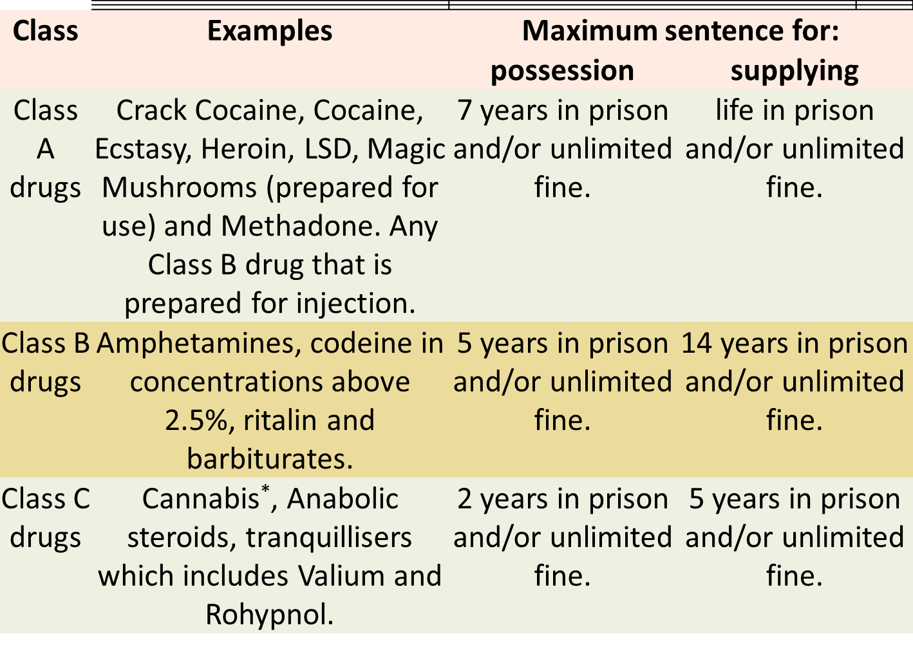

**Social and health problems caused by drugs and alcohol**

|  |  |  |  |
| --- | --- | --- | --- |
|  | TOBACCO | DRUGS | ALCOHOL |
| HEALTH  PROBLEMS | -Increases risk of getting over 50 medical conditions  -Can cause impotence in men | -Death through overdose  -Major cause of mental illness | -Causes liver and stomach problems  -Mental health problems |
| SOCIAL  PROBLEMS | -Watching loved ones die  -Makes people smell | -Dealers are criminals  -Major cause of gang crime | -Causes 41% of all deaths through falls  -65% of murder victims have been drinking |

**Christian attitudes to drugs and alcohol**

All against illegal drugs because…

* St Paul taught a Christian’s body is a temple and should not be abused
* Drugs have mental effects which make it hard to worship God correctly

They have two attitudes to tobacco and alcohol

1. OK if used in moderation because…

* Jesus’ first miracle was turning water into wine
* St Paul said Christians could drink in moderation
* Jesus drank wine at the Last Supper

1. Some practise abstinence because…

* Bible warns against drunkenness e.g. Noah’s drunkenness brought shame on the family
* Bible notes alcohol ‘impairs judgement, inflames passions and invites violence.’

**Key words**

**Sin –** an against the will of God

**Crime –** an act against the law

**Judgement –** act of judging people and their actions

**Law –** rules made by Parliament and enforceable by the courts

**Justice** – due allocation of reward and punishment, the maintenance of what is right

**Capital punishment –** the death penalty for a crime or offence

**Deterrence –** the idea that punishments should be of such a nature that they will put people off (deter them from) committing crimes

**Rehabilitation –** restore to normal life

**Retribution –** the idea that punishments should make criminals pay for what they have done wrong

**Reform –** the idea that punishments should try to change criminals so they will not commit crimes again

**Addiction –** a recurring compulsion to engage in an activity regardless of its bad effects

**Responsibility –** being responsible for one’s actions

**How to Answer Exam Questions**

**(a) DEFINITION QUESTIONS – 2 marks**

Write a complete sentence or two – give a brief example if needed.

Do not write any more than this.

**(b) DESCRIBE/OUTLINE/STATE – 4 marks**

This question will have a question in it e.g. Do you think Christians should use contraception?

Do not explain or debate. Give your opinion, (I agree/disagree because…). Support your opinion with **two** reasons (a religious teaching e.g. something Jesus or the Pope said, a quote from the Bible)

**(c) EXPLANATION QUESTIONS – 8 marks**

You must go beyond describing and explain your answer. Tell the examiner **WHO** you are talking about (e.g. Methodists, Roman Catholics), **WHAT** they believe or do (e.g. against abortion) and **WHY** they believe that (e.g. give a Bible quote to back up their beliefs). Do not include your own opinion. If the question asks why Christians have different opinions – start your answer with ‘There are different opinions because Christians/Muslims interpret the Bible/Quran differently’. This will gain you marks even if you know nothing else!

For **8** marks give **4** different reasons.

Your Quality of Written Communication will be assessed in all of these questions. **DO NOT** make spelling mistakes in this section. **USE** paragraphs, full stops, commas, capital letters etc

**(d) EVALUATION QUESTIONS – 3 + 3 marks**

This question will have a statement e.g. ‘Abortion s always wrong.’ It will ask for your opinion. You then have to give 3 reasons to support your view and 3 reasons why people might disagree.

Part 1 – I agree/disagree because…

Give 3 reasons to support your opinion.

Part 2 – I can see why some people might disagree with my opinion because…

Give 3 reasons to support this side of the argument,

**In all cases make sure you remember to use appropriate religious vocabulary (key words) wherever possible.**

**REMEMBER**

* Read the question
* Think about what you are going to write
* Write for **no more than** 1 minute per mark
* Never generalise. REMEBER NOT ALL CHRISTIANS BELIEVE THE SAME THING ALL OF THE TIME! Use phrases like ‘some Christians’ or ‘Catholics believe’